**Name:** Hill

**Assignment name: Find 3 websites that you like and 2 that you dislike**

**LIKE:**

NO.1[upup](http://upuptoyou.com/)

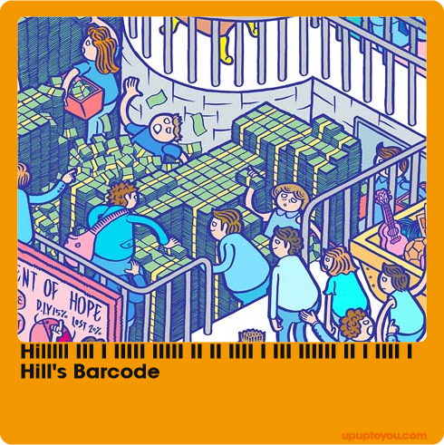

*UPUP (Holding Placards) is a manifestation of supportive attitude and the perseverance in hope. Every adorable UPUP character represents the people who support and enkindle you. In the world of UPUP, nobody is left behind or forsaken. At times when you need to confront challenges alone; UPUP characters will accompany you to walk through daunting trials and stride toward a brighter future. UPUP believes that many wonderful things await us to “uplift” their magnificence. Thus, the spirit of perpetual hope and infectious encouragement can positively impact the world. -----UPUP*

Illustration particularly interesting.  
Can intercept any picture made Polaroid style photos, very interactive.  
The operation is very simple, the website makes sense.

NO.2 [radugadesign](http://www.radugadesign.com/en)

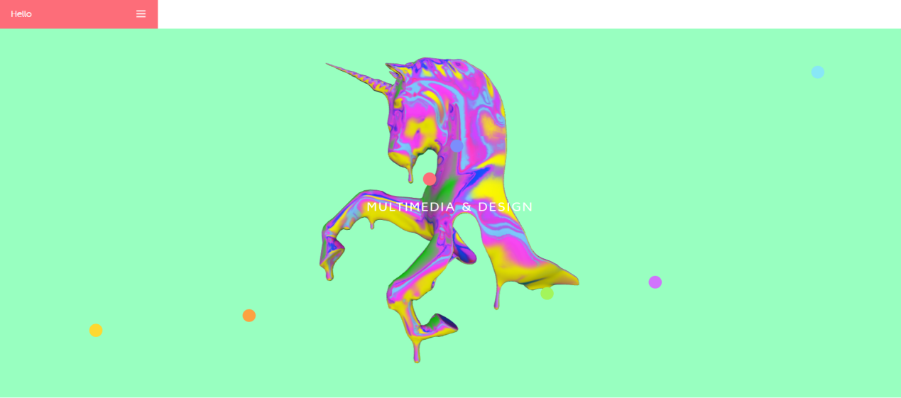

*Home is cool  
The way of interaction is very special.  
Loaded icons and mouse are very design sense.  
The interface is simple and easy to read.*

NO.3 .[makemepulse](http://2016.makemepulse.com/)

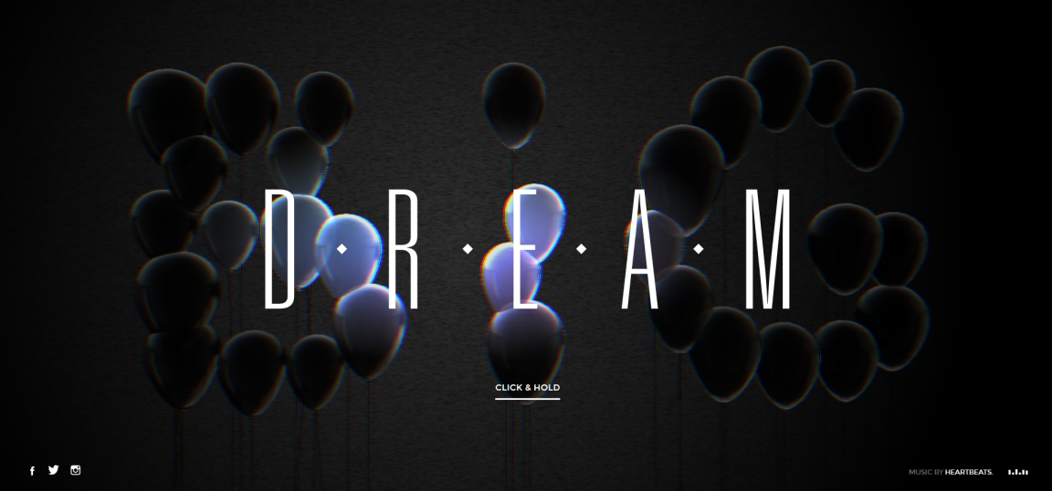

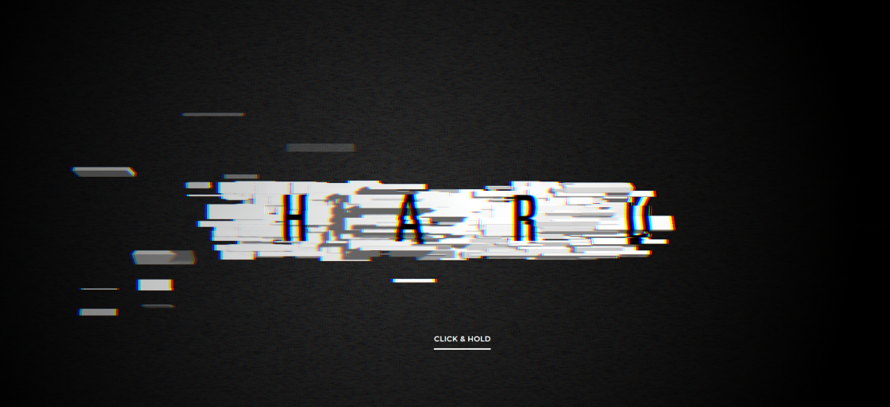

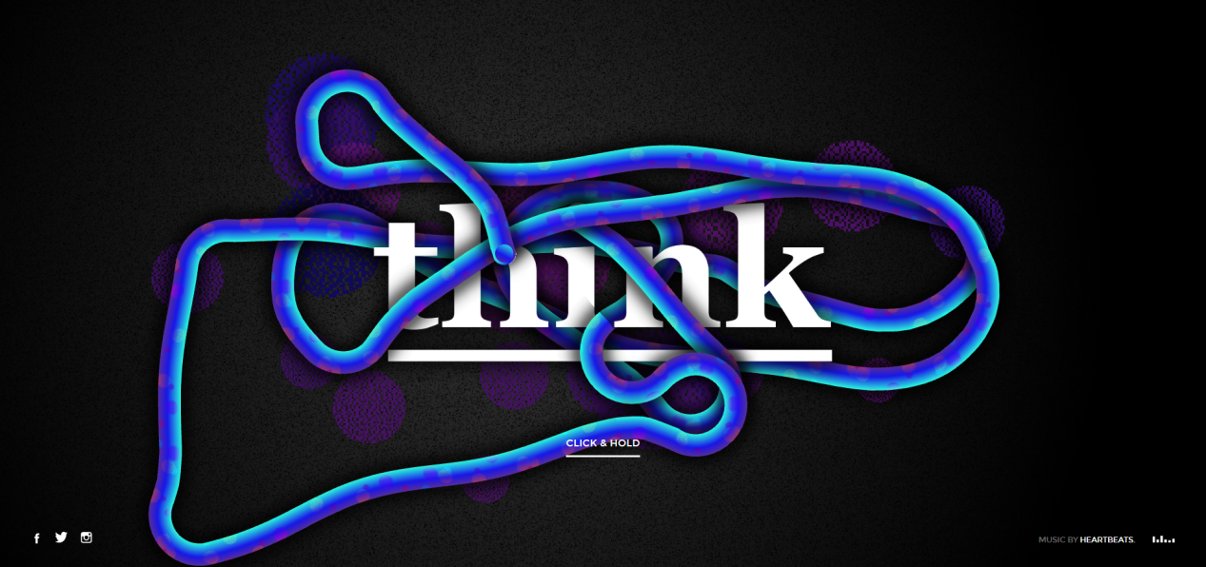

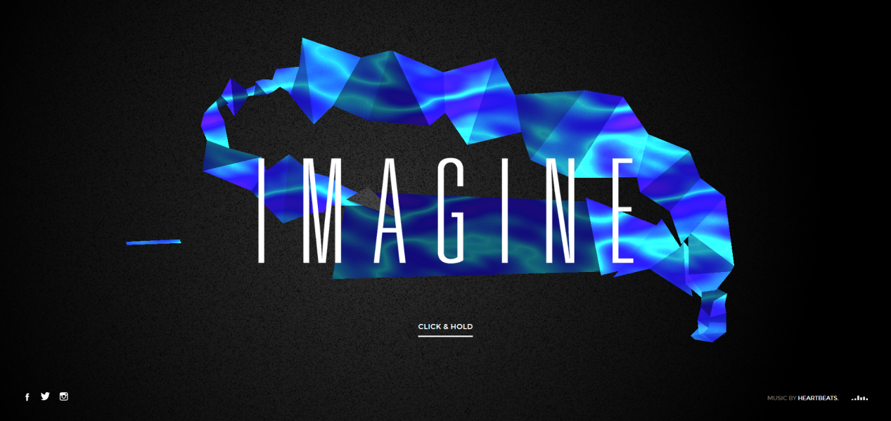

The sound is great, and the overall style is very take.  
Visual effects are great, every page is cool.  
The experience of each page is different, but the overall style is still very consistent.  
Interactive experience is great.

**DISLIKE:**

NO.1 **[After Life](http://heaven.internetarchaeology.org/heaven.html" \l "bottom)**

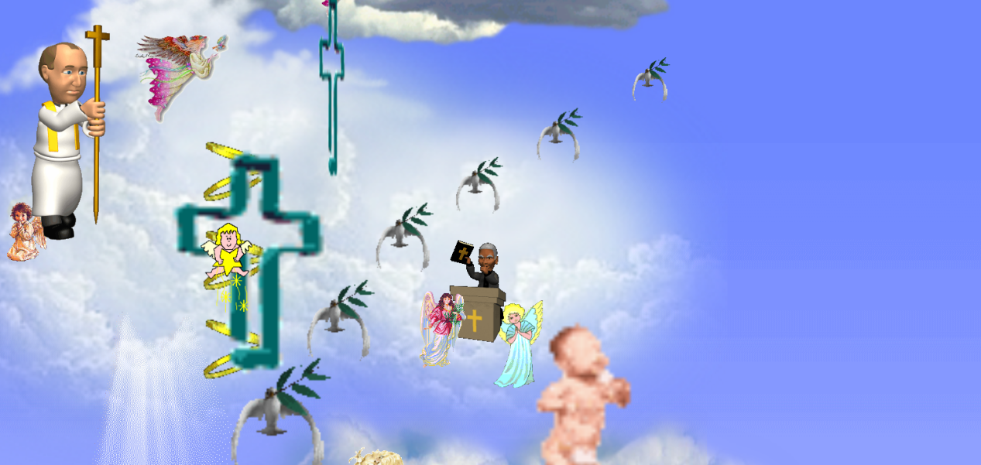

This website is nothing but animated pictures that keep scrolling upwards without any control from the user (and may malfunction in Internet Explorer).  There are no links or any type of navigation whatsoever.  What is the purpose of this website?! It’s Art???

NO.2 [amazon.cn](https://www.amazon.cn/)

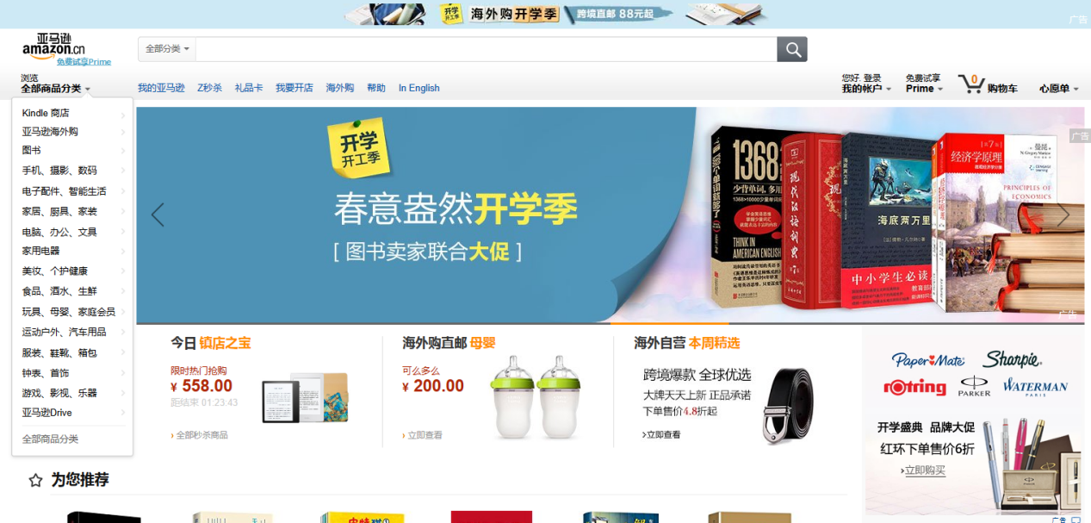

Amazon Chinese interface too ugly! Too crowded web content is too complicated, poorly formatted, a lot duplicate information.

Product details are not clear, it should takes a long time to read.  
Poor overall experience! ! ! Many shortcomings! ! !